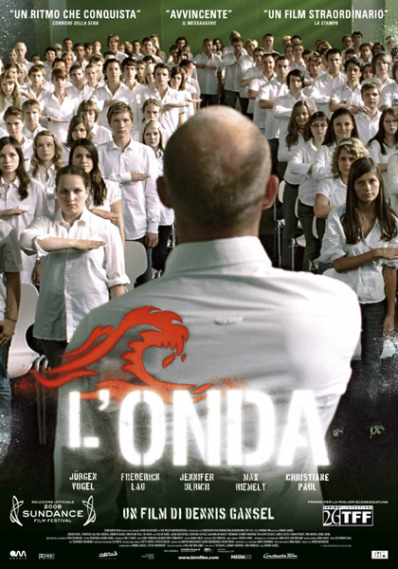
L'ONDA - DIE WELLE
Germania, 2008
Regia di Dennis Gansel
Musiche di Heiko Maile
Durata: 102'
Personaggi:
Rainer Wenger: Jürgen Vogel
Tim: Frederick Lau
Marco: Max Riemelt
Karo: Jennifer Ulrich
Anke Wenger: Christiane Paul
Miri: Karoline Teska
Dennis: Jacob Matschenz
Lisa: Cristina do Rego
Sinan: Elyas M'Barek
Bomber: Maximilian Vollmar
padre di Tim: Gerald Alexander Held
Storyline: High school teacher, Rainer Wegner, may be popular with the students, but he's also unorthodox. He's forced to teach autocracy for the school's project week. He's less than enthusiastic at first, but the response of the students is surprising to say the least. He forces the students to become more invested in the prospect of self rule, and soon the class project has its own power and eerily starts to resemble Germany's past. Can Wegner and his class realize what's happening before the horrors start repeating themselves?
Commento:
.......................................................................................................................................................................................................................................................................................................................................................................................................................................................................................................................................
Cosa ti ha colpito di più e perché?...........................................................................................................................................................................................................................................................................................................................................................................................................................................................................................................................................................................................................................................................................................................................................................................................................................................................................................................................................................................................................................................................................................................................................................................................................................................................................................................................................................................................................................
Un commento sulla colonna sonora?..........................................................................................................................................................................................................................................................................................................................................................................................................................................................................................................................
Un commento sulla storia e sulla tematica, e su com'è stata raccontata?............................................................................................................................................................................................................................................................................................................................................................................................................................................................................................................................................................................................................................................................................................................................................................................................................................................................................................................................................................................................................................................................................................................................................................................................................................................................................................................................................................................................................................................................................................................................................................................................................................................................................................................................................................................................................................................................................................................................................................
Quale riflessione ne puoi trarre?
..............................................................................................................................................................................................................................................................................................................................................................................................................................................................................................................................................................................................................................................................................................................................................................................................................................................................................................................................................................................................................................................................................

