There are many pubs run for (and often by) Irishmen/Brits/Aussies in Rome. The oldest are The Fiddler's Elbow, The Druid's Den, and Finnegan's Pub,

http://www.thefiddlerselbow.com/fiddlers_rome/rome_eng/welcome.htm
http://www.druidspubrome.com/
http://www.finneganpub.com/

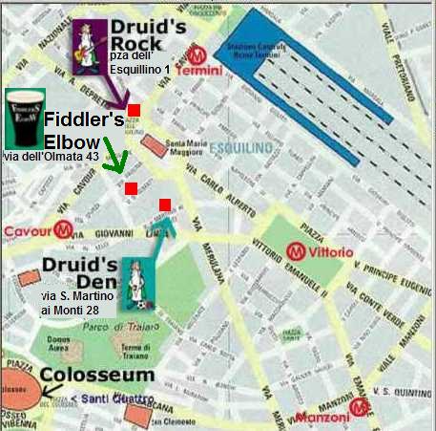

Two other Irish-style pubs: Molly Malone (via dell 'Arco di San Calisto 17), and Trinity College (via del Collegio Romano 6). Two English-style pubs: John Bull (corso Vittorio Emanuele 107a) and Mad Jack's (via Arenula 20). Two Australian-style pubs: Ned Kelly (via delle Coppelle 13) and Four XXXX (via Galvani 29). Finally , two American-style bars: The Drunken Ship (Campo de' Fiori 20) and Miscellanea (via delle Paste 110). These are all young people's places.

